APRA CPS 234 Compliance for Log360
Automate APRA CPS 234 compliance and fortify cybersecurity resilience for financial institutions.
Region: Australia | Type: Financial Services, Incident Management | Category: Compliance | Pricing: Free

Overview
The APRA CPS 234 compliance extension in Log360 helps organizations meet APRA Prudential Standard CPS 234, the mandatory information security standard from the Australian Prudential Regulation Authority for regulated financial entities by providing centralized log management, real-time threat detection, and user activity monitoring. The platform supports APRA CPS 234 requirements for information security roles, asset identification and classification, security capability maintenance, incident management with 72-hour APRA notification, control testing, and third-party security obligations.
For Information Security Roles and Responsibilities, Log360 tracks AD group memberships, GPO changes, policy modifications, and privileged access activity to evidence role-based access controls and governance enforcement across the regulated entity. To address Information Asset Identification and Classification, the platform monitors Windows program inventory, system services, computer auditing events, and system events to provide visibility into the asset landscape and support classification and lifecycle tracking obligations. The extension also supports Information Security Capability and Controls by providing capabilities that collects threat detection, anti-malware, network attack, and firewall events to demonstrate operational controls scaled to actual threat levels facing the APRA-regulated entity.

Key Features
- Control Testing and Internal Audit: Log360 captures event logs, process tracking, GPO changes, database audit trails, and vulnerability scan results to support control effectiveness testing and audit assurance activities.
- Incident Management and APRA Notification: Log360 detects security incidents from threat intelligence feeds, network attacks, and cloud storage events to support timely detection, evidence capture, and reporting obligations.
- Information Security Roles and Responsibilities: Log360 tracks AD group memberships, GPO changes, policy modifications, and privileged access activity to evidence role-based access controls and governance enforcement across the regulated entity.
- Information Asset Identification and Classification: Log360 monitors Windows program inventory, system services, computer auditing events.

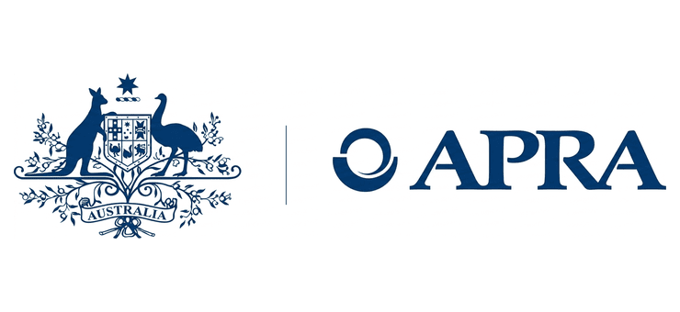
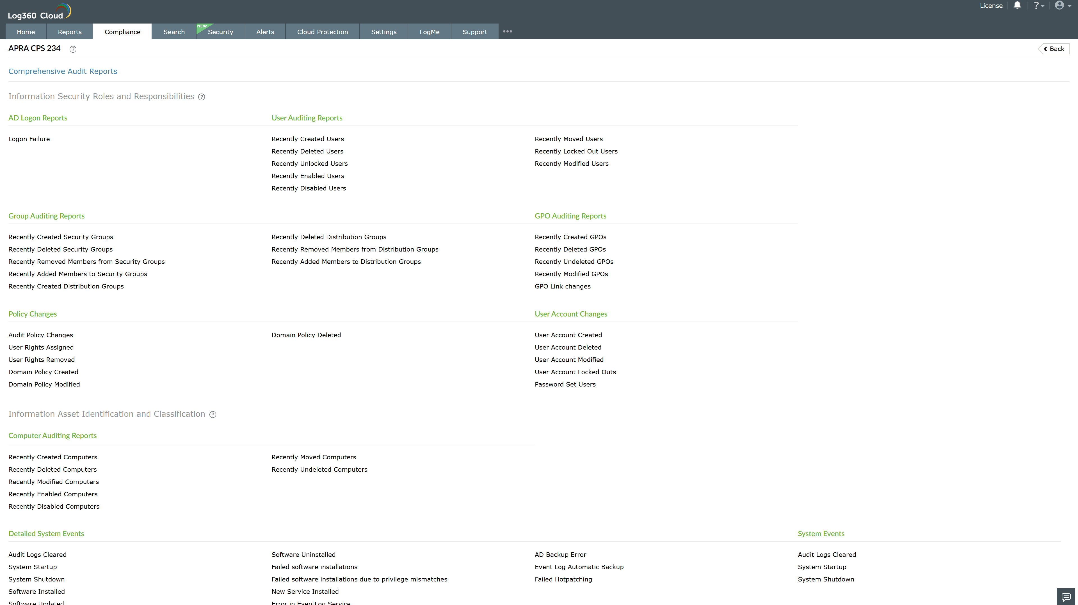
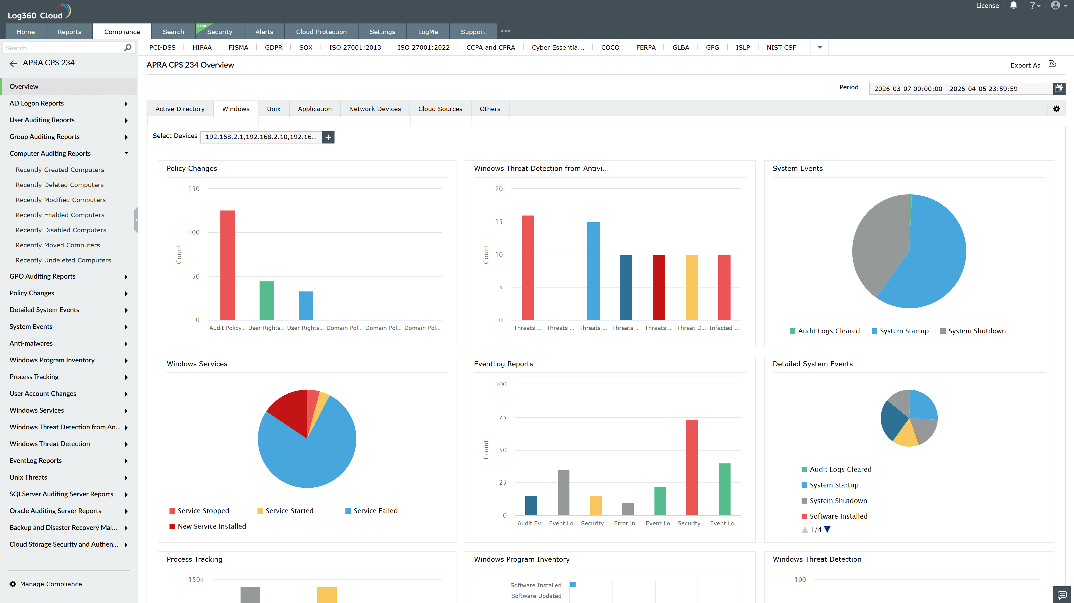
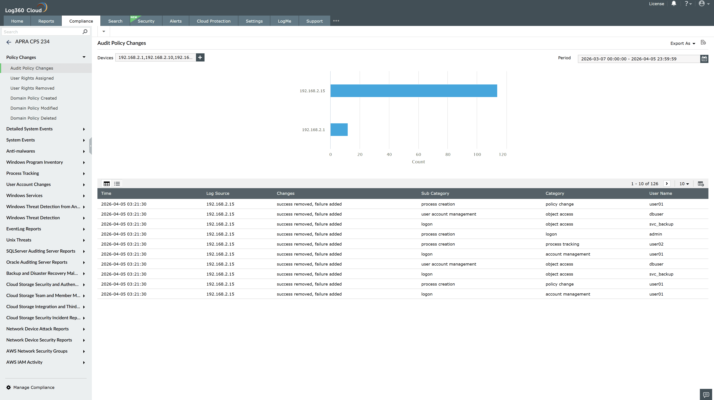
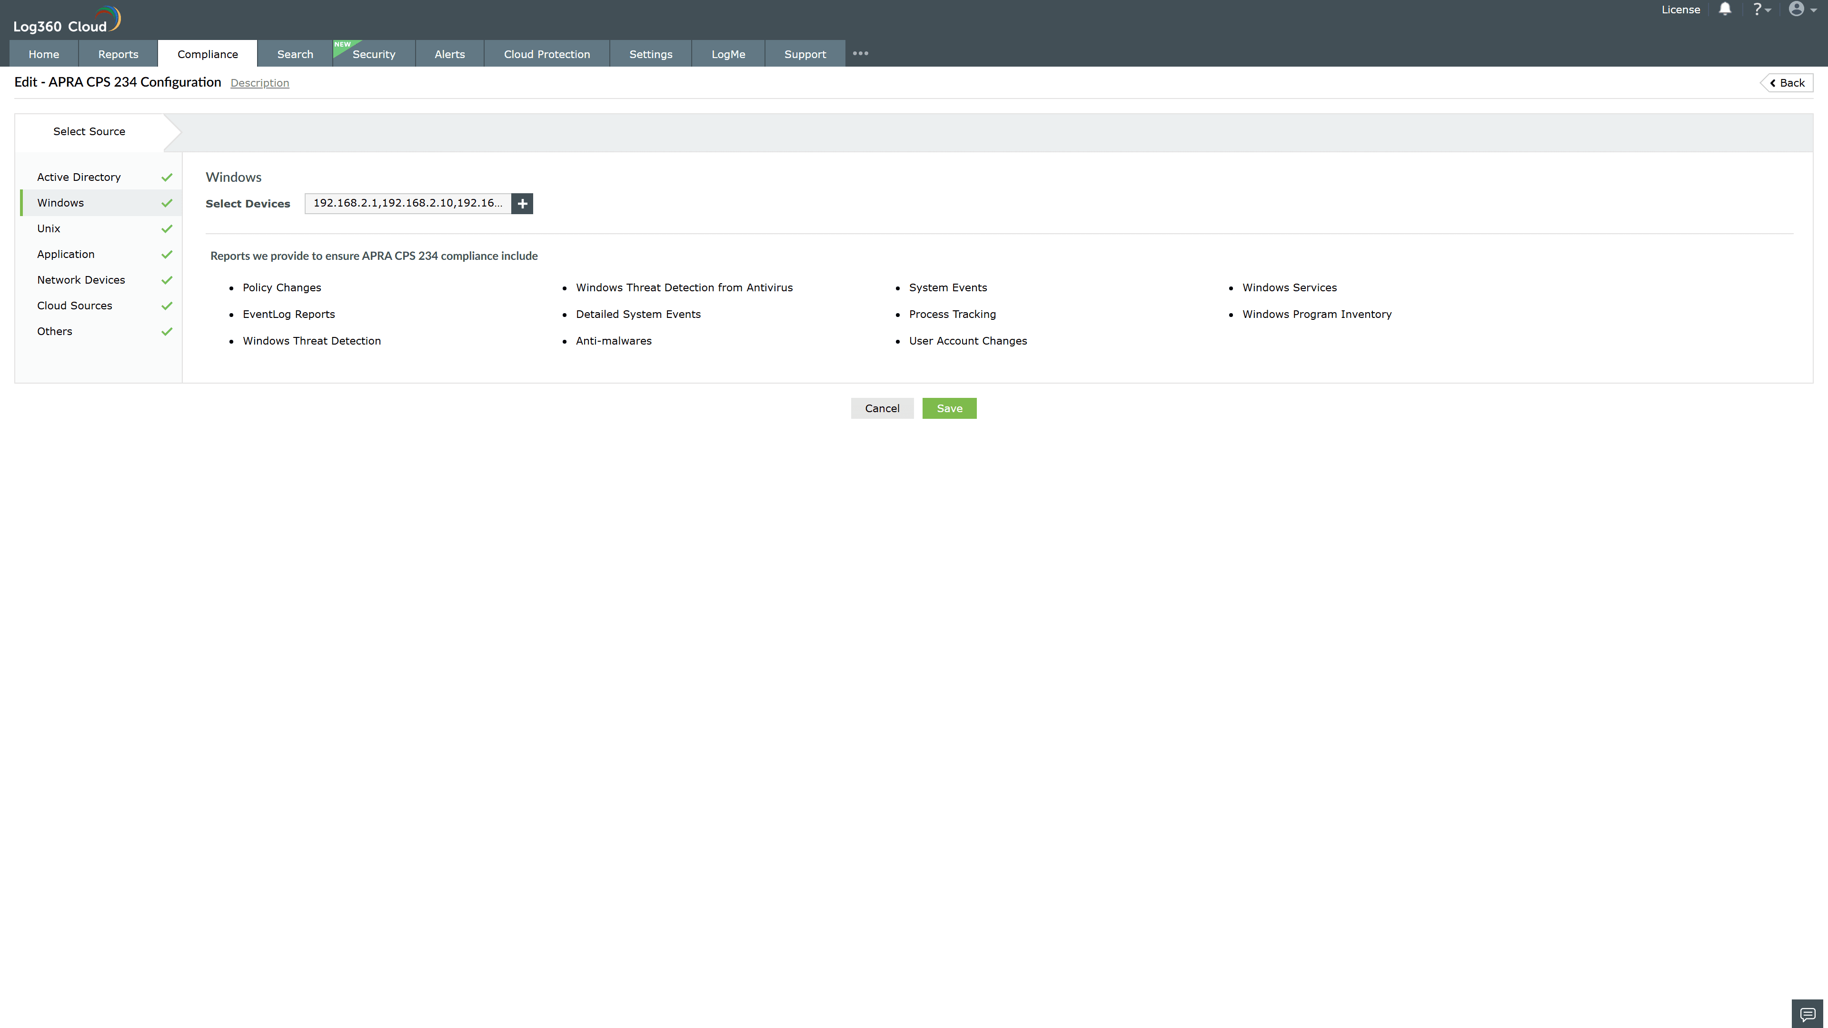
Valid Submission : Yes
Supported Editions : Free, Basic, Standard, Professional, MSSP
Help Document : https://www.manageengine.com/log-management/help/integrations/compliance-extensions.html
Help Video : Not provided
Tags : Log360, Compliance, Privacy monitoring, Data privacy, Regulatory compliance
Supported DCs : US, IN, JP, CA, AU, UK and EU
Privacy Policy:
Terms of Service:
Release Notes:
Predefined reports for the APRA CPS 234.

